**DESIGN AND SIMULATION OF LAN AND WAN TOPOLOGY USING CISCO PACKET TRACER**

**AIM :**

To design and configure a network topology for both LAN and WAN using Cisco Packet Tracer, involving 10-15 computers, switches, and routers. The objective is to simulate the transmission of a message from a computer in one network to a computer in another network, ensuring seamless connectivity and communication across different network segments.

**OBJECTIVE:**

Create and configure a suitable topology for both LAN and WAN using 10-15 computers, routers, and switches. Simulate the transmission of a message from one network to a computer in another network.

**PROCEDURE:**

**1. Topology Design:**

**LAN Configuration:**

Develop a network topology that includes at least 10 computers connected to switches, ensuring efficient local area network (LAN) connectivity.

Implement appropriate switch configurations to manage and expand the LAN segment effectively.

**WAN Configuration:**

Extend the network by connecting the LAN to another network using routers, forming a wide area network (WAN) structure.

Design the WAN setup to facilitate communication between the distinct LANs, ensuring reliable inter-network connectivity.

**2. Network Setup in Cisco Packet Tracer:**

**Add Devices:**

Place and connect 10-15 computers within the LAN segment.

Add a minimum of 2 switches to manage and distribute network traffic within the LAN.

Introduce at least 2 routers to establish WAN connectivity, linking the LAN segments across the broader network.

**Configure IP Addresses:**

Assign unique IP addresses to all computers within the LAN, ensuring they are within the same subnet for proper communication.

Configure the router interfaces with IP addresses that enable routing between LAN and WAN segments.

vnImplement routing protocols or static routes to ensure smooth communication between the different LANs through the WAN.

**3. Configuration Steps:**

**LAN Configuration:**

Connect the computers to the switches using appropriate network cables.

Assign IP addresses to each computer, ensuring that each address is unique and falls within the same subnet.

Link the switches to each other to enable network expansion and efficient device communication within the LAN.

**WAN Configuration:**

Establish the WAN by connecting the routers to each other.

Configure the router interfaces with IP addresses that facilitate WAN communication.

Set up static or dynamic routing to ensure the routers can successfully route traffic between the different LAN segments.

**4. Simulation:**

**Send a Message:**

Use Cisco Packet Tracer’s simulation mode to observe and test network activity.

Send a message from a computer in one LAN (e.g., LAN1) to a computer in another LAN (e.g., LAN2).

Monitor the message transmission to confirm successful routing through the WAN and proper delivery to the destination computer.

### **RESULT:**

**Network Topology and Configuration:**

**LAN Setup:**

Computers: 12 computers were successfully placed and connected within the LAN.

Switches: 2 switches were deployed to manage LAN connections.

IP Configuration: Unique IP addresses were assigned to all computers within the same subnet to ensure proper communication.

**WAN Setup:**

* **Routers:** 2 routers were configured to interconnect the distinct LANs, forming the WAN.
* **Router IP Configuration:** IP addresses were assigned to the router interfaces to enable LAN-to-LAN connectivity and inter-router communication.
* **Routing Protocols:** Static routes were implemented to ensure smooth traffic flow between the LAN segments through the WAN.

**Message Transmission:**

A message was successfully sent from a computer in LAN1 to a computer in LAN2.

The simulation in Cisco Packet Tracer confirmed that the message was correctly routed through the WAN and reached the intended destination.

**OUTPUT : SCREENSHOTS :**

**1. LAN Configuration:**

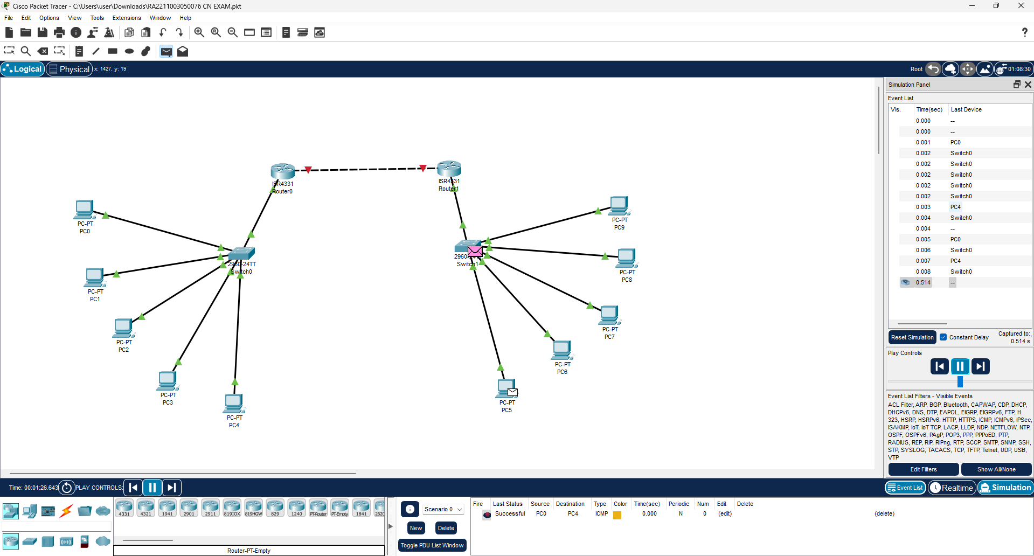

**2. WAN Configuration:**

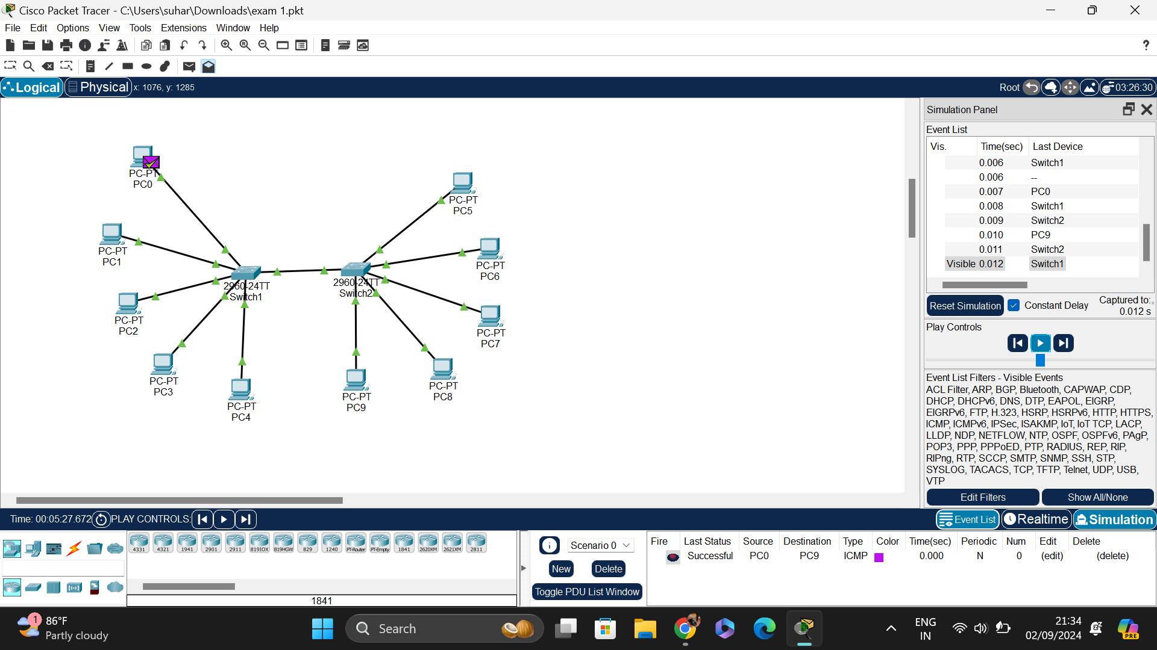

**RESULT :**

The network topology was successfully designed and configured using Cisco Packet Tracer, enabling seamless communication between LAN and WAN. The simulation confirmed successful message transmission across networks, validating the setup.

**GITHUB REPOSITORY LINK:**

[**https://github.com/Harshini-s-u/RA2211003050106**](https://github.com/Harshini-s-u/RA2211003050106)